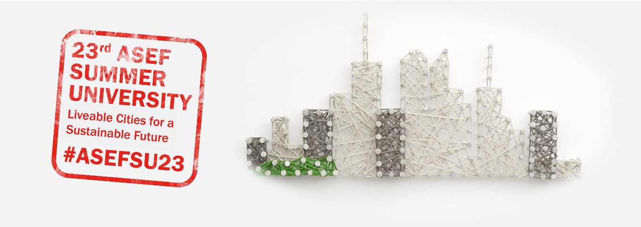
Dear Colleagues,

We are pleased to invite you to join the 23rd ASEF Summer University (ASEFSU23) Pitching Event & Awards Ceremony.

The 23rd ASEF Summer University (ASEFSU23) is an interdisciplinary Hackathon on “Liveable Cities for a Sustainable Future” for Asian and European young professionals & students. Implemented as a virtual programme between September and November 2021, this project connected young hackers, designers, innovators, urban planners and SDG experts to collaborate & develop urban solutions in three of the most populated countries in ASEM: Bangladesh, India & Pakistan.

Following a 3-week Pre-Hack Phase for ideation, ~90 Participants, aged 18-30 from 39 countries across Asia and Europe, are currently working to develop digital solutions on 3 challenges:
- Creating Clean Cities in Bangladesh
- Creating Healthy Cities in India
- Creating Accessible Cities in Pakistan.
Find out where our youth participants come from in these videos.

As a co-organiser of ASEFSU23, we cordially invite you to join
- Pitching Event, Sunday, 14 November, 10am UTC
- Awards Ceremony, Monday, 15 November, 8am UTC
where you can hear their final solutions presented to esteemed judges from Bangladesh, India & Pakistan!

If you are interested in joining these events, you can register at the following link: http://ow.ly/h8wu50GGIY9
Deadline: Friday, 12 November 09:00 UTC

Please find here the Project Overview and the Pitching Event & Awards Ceremony Programme for your reference. We are also happy to share with the Hackathon kick-off video to give you a feel for the project: https://youtu.be/kJMwARRM0Gw

We would like to thank you in advance for your support towards our participants.
Warm regards,

