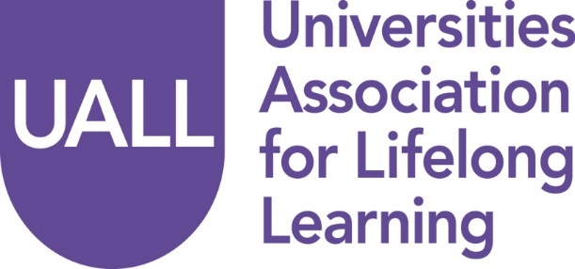

Annual General Meeting 2016

Council Meeting

Ambassadors Hotel, Upper Woburn Place, London   
Thursday, 24 November 2016

###### Programme

9.30 – 10.00 am Coffee and Registration

10.00 am **Welcome**   
 The Rev’d Canon Professor Peter Neil, UALL Chair   
 Vice Chancellor, Bishop Grosseteste University

10.15 am **UALL AGM and Council Meeting**

11.15 am Refreshments

**The AGM and Council Meeting will be followed by**

The 2016 UALL Annual Seminar:

***Social mobility and the mature learner: UK and international   
perspectives***

11.35 – 4.00 pm

For details see the separate Seminar Programme