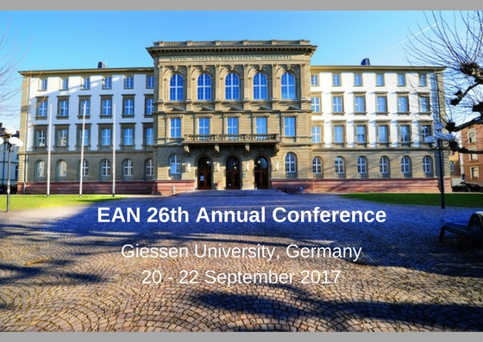

Abstract Submission Guidelines

The deadline for submissions is Friday 2nd June 2017.

All abstracts must be submitted using the template below.

Title:
Less than 20 words. Please ensure that your proposal title and summary provide a good guide to the proposal’s content.
Authors:
Please provide author’s/authors’ title, first name and last name.
Presenters:
Please provide the required details (name, position, affiliation, country, email address) for all presenters who will be at the conference.
Affiliations:
An affiliation (institution/organisation and country) should be included for each presenter.
Abstract text:
Must not exceed 300 words (excluding title, authors and affiliations)
Please do not include references or footnotes in your summary
Font:
All abstracts should be submitted in an accessible, sans serif font e.g. Calibri, size 12 minimum.
Language:
English
Thematic strand:
Please indicate which of the four thematic areas you will be presenting under. Refer to the call for proposals for details.
Save your file as: Surname_Firstname.pdf
Completed abstracts to be sent to eangiessen2017@arbeiterkind.de

Abstract Submission Form
Title of abstract:
(less than 20 words)
Format of Presentation
(Paper, poster, workshop, project, other…)

Focus of this proposal:

(Theory, research, policy or practice)

Name of author(s):
Presenter(s) details:
- name
- job title
- organisation
- country
- email address

Please list ALL presenters
Thematic strand:
Please state which of the four thematic strands is addressed by this proposal, referring to the call for proposals

Abstract:
Your abstract must use an accessible, sans serif font, size 12, and not be more than 300 words in length

