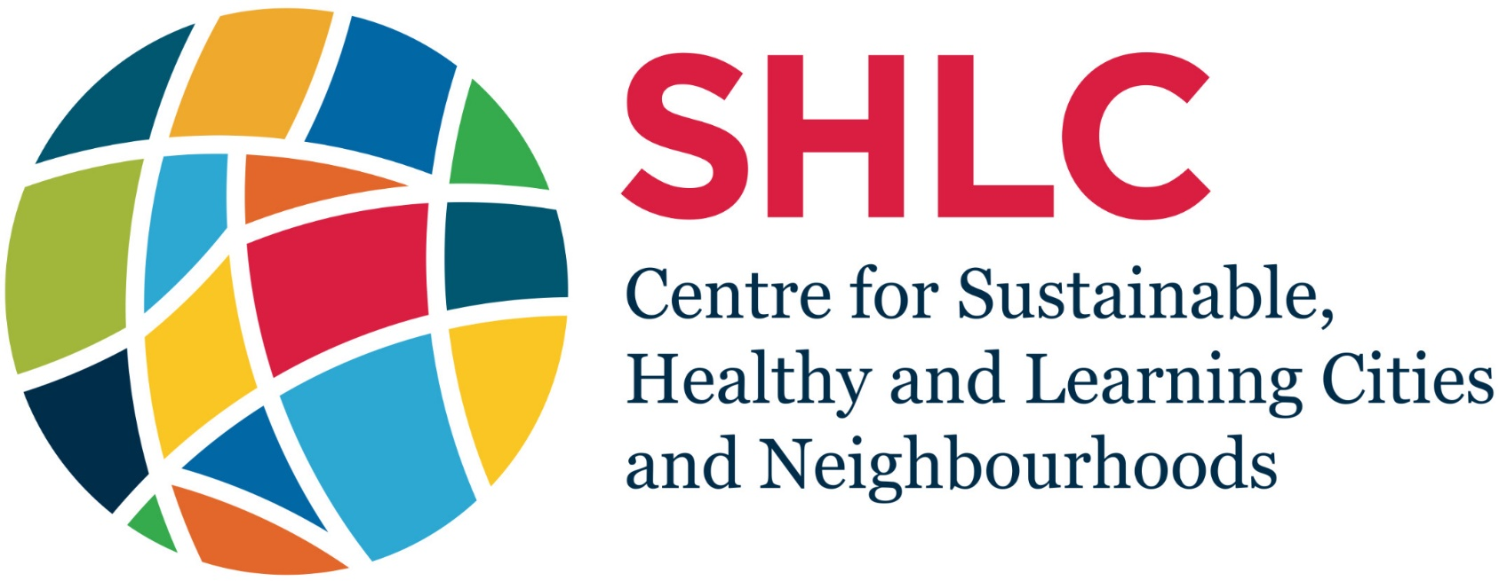

SHLC CAPACITY DEVELOPMENT ACCELERATION FUND/VISITING FELLOW EXCHANGE PROGRAMME – APPLICATION FORM
Version 2.0 - August 2018

FORM TO BE COMPLETED AND RETURNED TO:
SHLC-INFO@GLASGOW.AC.UK

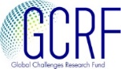
Title of project:

Project Summary (50 Words)
This information should be an effective lay summary of your planned project that is suitable for posting on the University of Glasgow website.

Project Type (please tick one):
Visiting fellowship/exchange Research project
Knowledge mobilisation Research management

Name of Lead and Co-Applicant:

Organisation:

Please tick here if you are applying as an Early Career Researcher:

Email: Telephone:

ODA Recipient Country Partners
Please list individual names and institutional affiliations.

Academic Partners:

Non-Academic Partners:

Total grant requested:

Total contributions from partners:

- Description of Project (max. 300 words)

The Capacity development acceleration fund (CDAF) and visiting fellow exchange programme support pilot projects and secondments/exchanges that complement the core work programme of the SHLC programme. These projects may take a number of forms:

- Extending an aspect of current work of SHLC into a new context by undertaking new research
- Enhancing the capacity of other researchers (especially early career researchers) beyond the core SHLC team, through applying SHLC approaches
- Translating the findings of SHLC into community settings with non-academic beneficiaries through engaging in socially impactful activities

In all cases, it is important to demonstrate long term academic and social impact

Please give a brief outline of the project that you propose, which of the above forms the project will focus on (it may be a combination of one or more) and list the names of academics who will be involved.

- Project Summary and Objectives (max. 500 words)
Please describe the proposed activities, stating the objectives of the project, why the activities are needed, how the work will enhance the capacity of academics in your institution (particularly early career academics) and how the activities will enable non-academic partners to use the research/project activities to effect change in society and/or the economy.

- Capacity Strengthening and relationship to strategic priorities (max. 200 words)
Please provide details of how this project will build the capacity of, where relevant, individuals, organisations and/or institutions. Applicants should clearly explain how the project will enable the development of these skills within the team and how the project will capture the success of the capacity strengthening elements of the project.

- Evidence of Demand from ODA Recipient Partner Communities (max. 350 words)
Please describe how the proposed project meets the needs of communities in the ODA recipient partner country with whom you are working and describe the role of ODA country collaborators in developing the project idea. If this is an exploratory project, applicants should describe how they will ensure local collaborators are involved in all stages of the project.

- Project Planning – Timeline & Risk Mitigation (max. 300 words)
Please set out the timescale for the proposed work, giving a schedule for the different phases and an indication of how you would mitigate against foreseeable risks.

- Outputs and Outcomes (max. 300 words)
Please clearly outline the intended outputs (deliverables) and outcomes (changes that come about related to the project), ensuring that they are appropriate and realistic to the proposed activities.

- Tracking, Measuring and Evaluating Impact (max. 300 words)
Please set out how you will gather data about your activity and how you will identify, measure and demonstrate non-academic impact.

- Sustainability (max. 200 words)
Please describe how this project fits into the context of your existing relationship with the user organisation(s) (e.g. NGOs, community organisations, city administrations and the private sector) and how you will go about ensuring that further relevant opportunities for collaboration are identified and capitalised upon.

- Dissemination (max. 200 words)
Please propose how you will disseminate the outcomes of your research/project activities. These could take the form of both traditional academic outputs, blogs, social media outlets and a raft of other mechanisms. We are looking for innovative approaches that we reach the maximum possible audience.

- Justification of resources (max. 200 words)
Please provide a short narrative explanation of the costs of the project, including any cash or in-kind contributions from the user organisation(s). NOTE: Please provide a breakdown of the budget and expected expenditure in the costing sheet attached at the back of this form.

- ODA Compliance Statement (max. 300 words)

This section is closely linked to Section 2. You must state all countries involved, their position on the DAC list, and the communities within those countries that will be impacted by your activity. It is not sufficient to only state your work is taking place in an ODA eligible country – you must address how the project fits into the country context (local challenges, socio-political structures, skills or knowledge gaps relevant to the country or countries in question, etc.). If the project is UK-based, applicants must describe in detail how the project is relevant to LMIC challenges and how the outcomes from the project will address those specific challenges. Priority will be given to proposals that focus on low income countries, or on less-advantaged groups within middle income countries.

Costing Pro-Forma

TYPE OF EXPENDITURE | DETAILS | UNIT COST | SUBTOTAL
Travel

Accommodation

Subsistence

Consumables

Venue Hire

Other

TOTAL |  |  | £

